# Blog Assignment #1

These days, especially at affluent universities like SMU, incoming freshman are buying up Apple products like there’s no tomorrow. Apple has made great strides and has increased their market share amongst college students astronomically in the last few years. Back in 2005 their market share was a mere 14% and by 2010 it was up to 47% for college students (CNN). How has Apple gained such popularity, is it a fad or is it here to stay? The question of whether it is a fad or not is very disputed amongst individuals. Despite being an avid Apple fan and early adopter who owns or has owned just about every Apple product their ability to compete in the market is soon to be a whole lot harder. We all are well aware that Steve Jobs has passed, but under Tim Cook as CEO Apple has been unable to innovate to the level that is necessary for Apple to remain a dominant player in the market. They may have introduced many revolutionary products such as the iPod, iPad, iMac, and their oh-so-loved iPhone but they have stopped being visionaries and rather are found copying other brands. Apple has sneakily copied either other brands or successful tools developed for iOS and later integrate it into their product. While this seems great from a user point of view, this adversely effects the willingness of their developers to create applications knowing that if it becomes successful Apple may very well copy their idea. 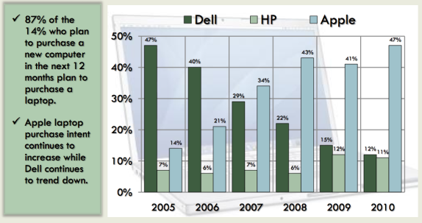

Apple products are becoming a part of our everyday lives. From the iPhone, iPad, Macs, to Apple TV’s they’re integrated for the “best user experience” possible. This allows, for the working individual, the ability to work across devices and expect how it will work. At my work either you’re working on a Mac or a linux laptop (very close to OS X). This allows us to increase our productivity by having a secure(r) environment for us to deal with private information for our customers, intuitive interfaces, and continuity between our customers and us.